**The Implementation of Chinese Character Version of Tetris:**

**C++ QT Version**

Class: CSC3002

陈雅茜 Yaqian Chen 117010032

胡冰彦 Bingyan Hu 117010090

刘浩翔 Haoxiang Liu 117010164

刘家祯 Jiazhen Liu 117010268

肖淞月 Songyue Xiao 117010305

周喆媛 Zheyuan Zhou 117010423

Date: 2019.5.19 ( Sun. )



**Content**

**Introduction** ..................................................................................................

1.1 Abstract ..................................................................................................................

1.2 Synopsis of Program Structure and Function ........................................................

**Implementation** .............................................................................................

2.1 Graphic User Interface ...........................................................................................

2.1.1 Start interface ...............................................................................................

2.1.2 Game interface .............................................................................................

2.1.3 End interface ................................................................................................

2.1.4 Interface for Network Version .....................................................................

2.2 Game Algorithm ....................................................................................................

2.3 Network ..................................................................................................................

2.4 Multithreading ........................................................................................................

**Test Result**

**Conclusion** ......................................................................................................

**Introduction**

**1.1 Abstract**

Tetris is a world popular game created by Russian computer scientist [Alexey Pazhitnov](http://www.baidu.com/link?url=uA6zvKDJMxRLn8gn5ox3jewRVJKaVu93ni6AT3M0isrge3Ae2dt1tISkotRi0Cdd7gU5yeS6R8_sQJ1oW8NhHPKse__nUhTg0-AqoovitZrFCOn8evZp-6xUDzN2ITJ7) in 1985. Then, it has been translated into different versions. The basic idea of Tetris is moving the falling squares and combining them together to form a complete line. The game ends when the squares come to the top of the board.

Our team creates a brand new version of Tetris: Chinese Character Version of Tetris. And the instructions are as following:

The system will generate squares containing part of / Chinese character in it once a time, and player need to use arrow keys on their board to control the direction. Player is encouraged to put related squares together to combine an existed character. The game ends when the square touches the top of the board.

This game is meaningful to promote people’s understanding of Chinese character and culture. It is a interesting and creative game for players and it is also a challenge and significant project for our team to implement.

**1.2 Synopsis of Program Structure and Function**

Our program consists of three main parts: graph user interface (GUI), character board and networking. The graph user interface interacts with the player directly. It allows the user to select different modes and play game through push buttons. It also displays the current score and level of the ongoing game. Character board implements the game’s main logic. It receives the signals emitted from GUI or keyboard to control the game flow. Networking allows users with different IPs to play the game simultaneously.

**Implementation**

**2.1 Graphic User Interface**

2.1.1 Start interface

The start interface is the first interface when run the program implementing by QT Widget.

The actual start interface contains two parts: main function and start_interface class.

For in main source file, where the whole program starts, the system will firstly create a start_interface object widget and re-sizes the widget(window) into size 700 * 600. Then, the opacity is set by the method setWindowOpacity in QPalettle class.

Figure 2.1.1: The background figure implementation

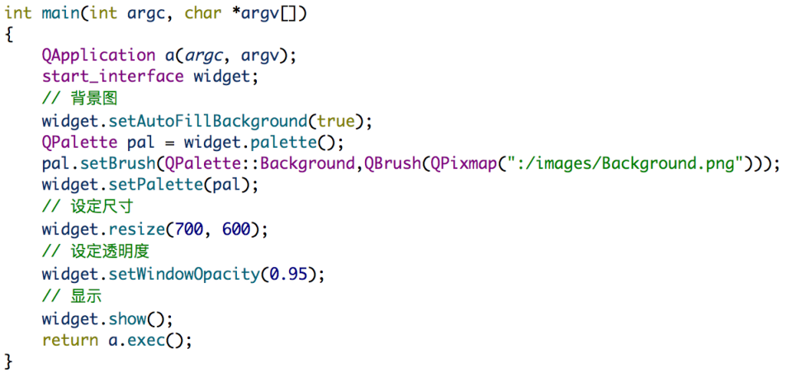

Considering the object-oriented property of C++, we chose to realize the start interface by constructing a class, which inherits QWidget as parent class.

When creating a new object of start interface class, the interface is supposed to contain following data fields: a topic diagram, a main background, three push buttons for user to choose modes, a push button to show the instruction and a button to control the background music.

For the topic diagram, a QLable type object is created to fix the position of topic diagram, then by using the QPixmap method, the relative address of the topic diagram is transported.

Figure 2.1.2: The topic diagram implementation

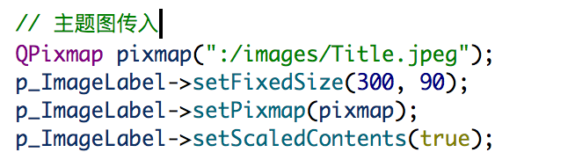

For the main background, instead of constructing in the start interface, it is moved to main window and be painted by QPalettle as the reader can see from above.

For the four push buttons, the <QPushButton> is included for creation. The setFixedSize method fixes the height and width of the button; the setText method determined the mode name printed on the buttons; the setObjectName assigns names for these four buttons for later mode determination in the board interface.

Figure 2.1.3: The mode buttons and help button implementation

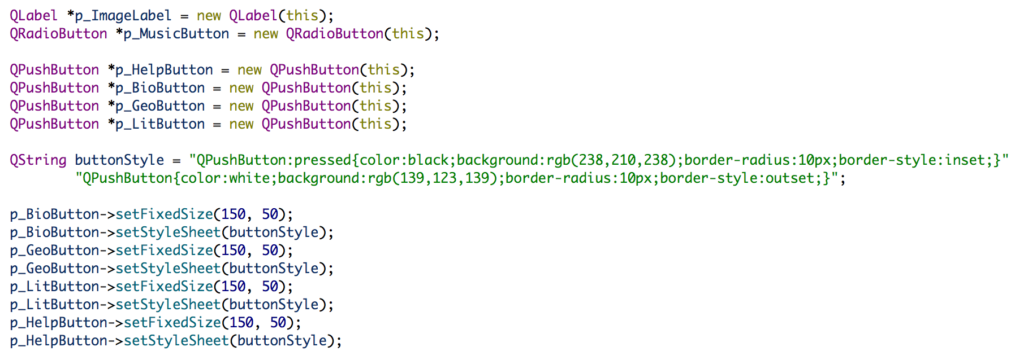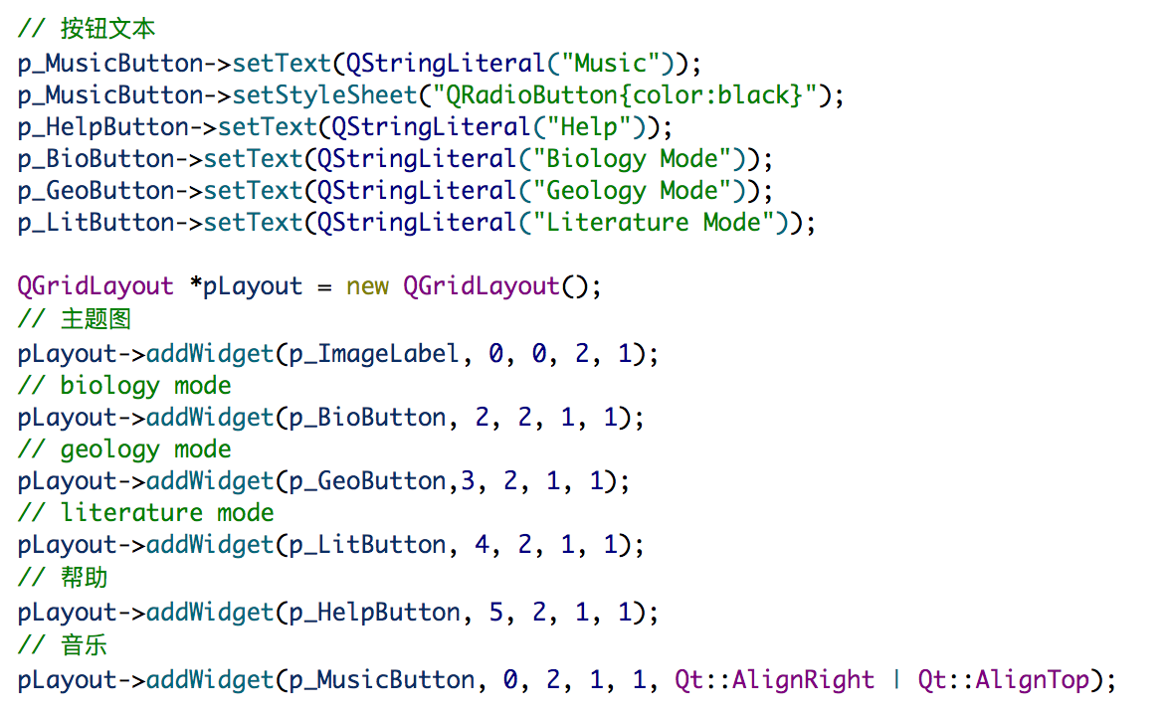

The background music control is implemented by QRadioButton, QMediaPlayer and QMediaplaylist. And the application of signals and slot realizes the play and stop of music by clicking the radio button.

Figure 2.1.4: Music implementation



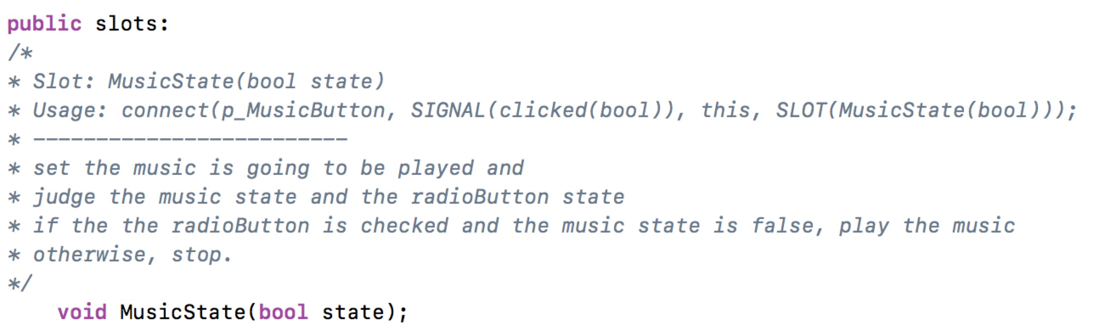

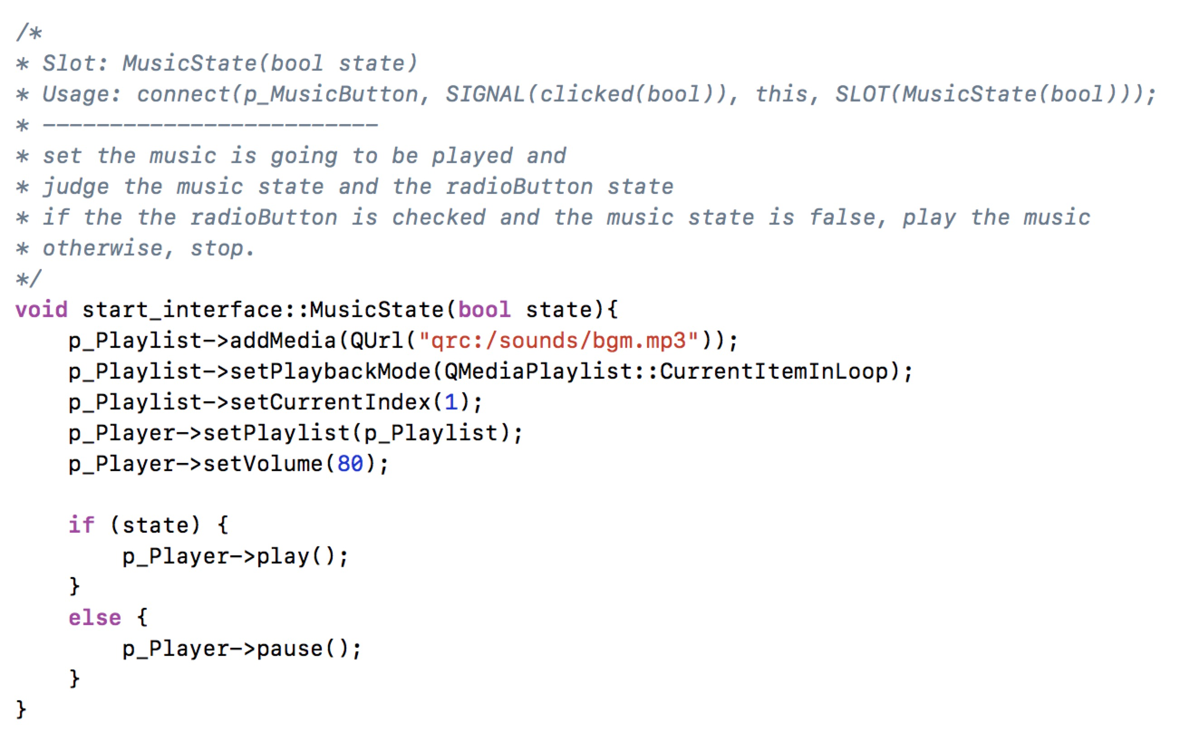

Grid layout is used in this class to regulate the structure. To promote the vision effect, spacing is set between buttons both horizontally and vertically.

Figure 2.1.4: Grid layout Addition

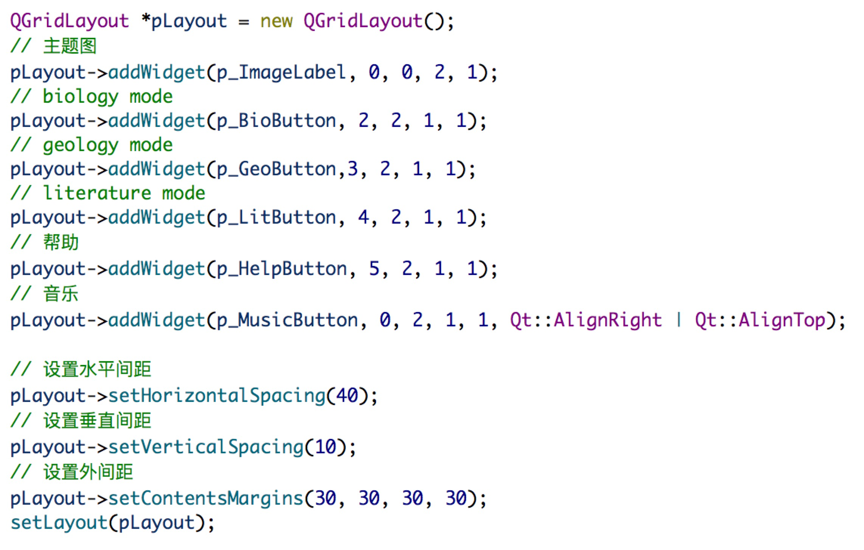

2.1.2 Game interface

Game interface is the interface that shows the game board, game score and related buttons. The game interface is implemented by a “game_interface” class which inherited from the “QWidgets” class.

The game interface consists of many widgets. First, it has several buttons, including “startButton”, “pauseButton” and “quitButton” to control the game status. Second, “foreshowLabel” is designed to show the next character. Third, two LCD numbers “scoreLcd” and “levelLcd” display current score and level, respectively. Fourth, several text labels mark different LCD numbers. A private method “createLabel” assists in the creation of text labels. Last, the main game board is implemented by “CharacterBoard” class.

|  |
| --- |
| Figure 2.1.5: The implementation of method “createLabel” |
|  |

As for layout, the whole interface is distributed as a grid layout. Some horizontal layouts are inserted into the main layout.

|  |
| --- |
| Figure 2.1.6: Layout of the game interface |
|  |

There are also signal connections between classes in order to control the game flow via this interface or switch to other interfaces. There is a slot called “displayGame” which receives signal emitted from the start interface. When the user clicks on any mode selection button in the start interface, this slot will be activated and display the game interface. “scoreLcd” and “levelLcd” receive signals from the “CharacterBoard” class. “leftButton”, “rightButton”, “downButton”, “startButton” and “pauseButton” emit signals to the “CharacterBoard” class. “quitButton” control the whole program directly by calling “quit” method in the “QApplication” class.

|  |
| --- |
| Figure 2.1.7: Signal connections in the game interface |
|  |

2.1.3 End Interface

The end interface is consisted by three different background pictures and a LCD display widget.

For the background pictures, the size of the picture is fixed by both setMaxmunSize method and setMinimumSize method. The program will also judge and generate corresponding picture by analyzing final score in a if-else statement.

Figure 2.8: Background figures size control and determination

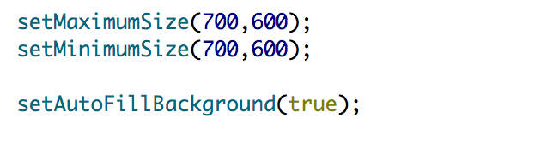

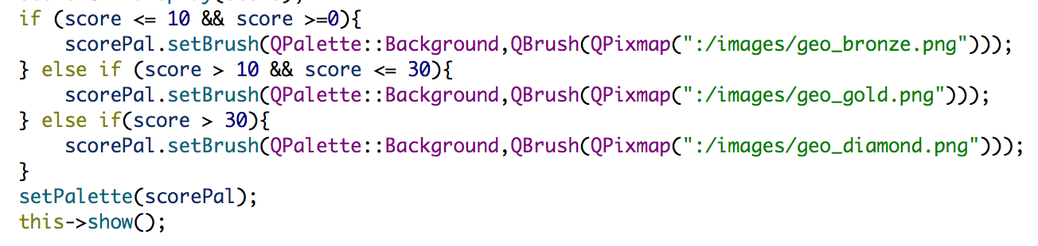

For the score display, it is realized by QLCDNumber class. In order to fix the score display in the right position in the picture, QVBoxLayout class and addSpacing method are used in the program as following:

Figure 2.1.9: Score position determination in end interface

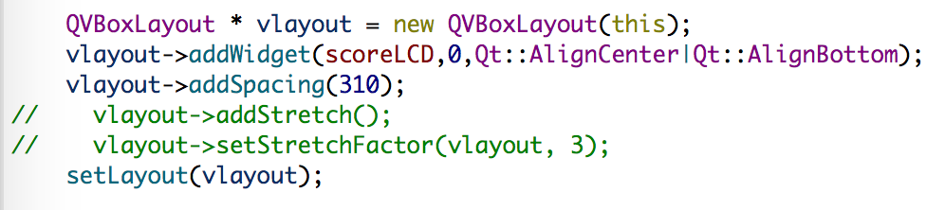

And in order to adjust the LCDNumber vision effect, displayed digit number, size, following code is used:

Figure 2.1.10: LCDNumber display effect adjustment

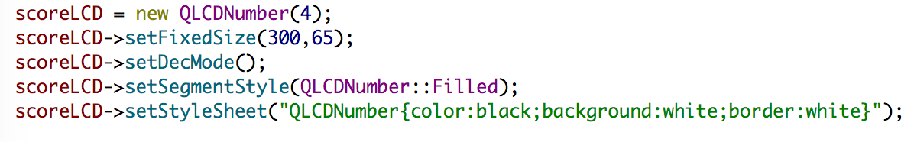

The signals and slots between character board and score interface, realizes different end interfaces:

Figure 2.1.11: connection of signal and slot in end interface

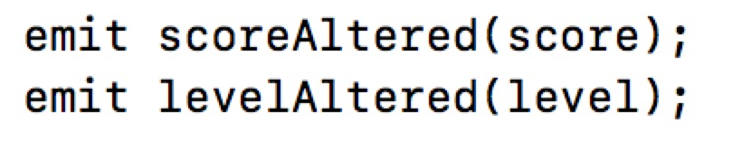

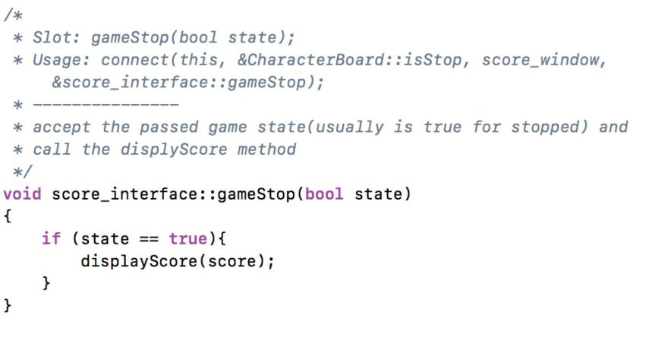

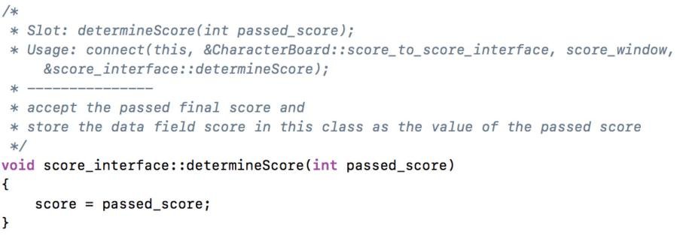

**2.2 Game Algorithm**

This part describes the overall logic of the playing process, basically how the characters fall down and then are checked, combined, and removed, in which we mainly used object-oriented programming paradigm.

In character. h, we defined a class called Character whose objects can represent Chinese characters. Since Chinese characters all have certain kind of structures, we must have data fields to represent the components of characters. In total, we take 7 kinds of structures into consideration (see picture below):



As can be seen clearly, these five data fields are needed: left, right, above, below, middle. The content and structure of character objects are also encapsulated into the class.

In character_board.h, a class called CharacterBoard is defined, which works as the place where characters appear and interact with each other. The functions and instance variables in this file can be divided into two parts. One is responsible for the appearance of the board, the other takes charge of the control of the game.

When the player selects a playing mode at the start interface, mode_selection will be called. This function passes the information about mode selected, and then calls the function buildDictionary to read the dictionary (.txt file). The txt file contains all the characters from biology, humanity, geology and basic fields. Its contents are organized as below:

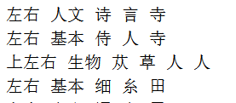

buildDictionary will read this txt file line by line. For each line, we create an object of Character type and store the information in this line into the object. One thing to notice is that we redirect the standard input stream to make sure Chinese characters can be read and encoded correctly. If a certain character doesn’t have a certain component (for example, “级” does not have a “middle”), that data field will be simply set to an empty QString. After we finish initializing all the data fields of a Character object, we need to store it. We declare three global maps (one for each category) whose keys are the components and the values are vectors containing all characters which have that component. This makes use of the idea of hashing. Later when we check whether a component piece can be combined and removed, we will only need to loop through the vector for that component instead of all the characters, which increases the efficiency.

When the Start / Pause button is pressed, the start function will be called, in which it checks whether the isStarted signal is on first. If so, it will call pause function to pause. If not, the isStarted signal will turn on and initialize all parameters related to grading. Meanwhile, it will emit signals of piecesRemovedAltered, scoreAltered, and levelAltered to the labels in window.cpp. Lastly, it will start the timer.

The flow of the function is coordinated by function timerEvent. Every time the timer (a QBasicTimer object) times out, this function will be called. We will determine the next step of action according to the value of several integer variables: waitingForRemove, waitingForAdjust, waitingForNewPiece. If waitingForRemove is 1, it means that the piece has dropped to the bottom and it is waiting to be checked and combined if possible. If waitingForAdjust is 1, it means we are waiting to remove the combined pieces and adjust the positions of the rest pieces. If waitingForNewPiece is 1, it means all combination, removal and adjustment have finished for this current round and we are waiting to generate a new piece. If they are all 0, oneLineDown function will be called to move the character one line down, in which this operation was implemented by tryMove and droppedPiece functions.

When a character is generated, we need to control how it moves in the character board, which was implemented by keyPressEvent. This function will be active when there exists a character falling in the character board, which means that it has not fallen down to the bottom and the game is under started state. There are 4 keys useful for moving. If left key and right key are pressed, tryMove will be called. If the space bar is pressed, the character will drop to the bottom directly, which will be implemented by dropToBottom. In dropToBottom, we will try to move the character as far as possible and then call droppedPiece. If the key, D, is pressed, the character will be moved one line down faster, which is simply implemented by calling oneLineDown.

Next, we will introduce how the pieces are checked, combined and removed. The function removeCombination tries to find all the combinations currently on the board. We loop through the vectors in that mode’s map corresponding to piece components to be checked. For each character in the vector, we will check whether combination can happen. If combinations are found, it will set the timer to wait for adjustment. Through the coordination of timerEvent, we will call function adjustment(). In this function, we remove the combined piece and adjust the positions of the pieces left. For the pieces whose positions have been changed, we need to check again to look for more removal (consecutive rounds of combinations and removals). When there are no more pieces that can be combined, we will generate a new piece.

In order to paint the pieces out, we override the function paintEvent() (inherited from class QFrame). Every time we call update(), we are actually calling paintEvent and repaint the whole board. The drawing of the pieces is divided into two parts. In the first part, we draw the pieces that have dropped down to the bottom. In the second part, we draw the piece currently falling. The pieces are painted one by one using the function paintPiece.

The most difficult part of game logic is to use the count-down timer to control the program flow. We used several integer variables to control what is the next step to do after the timer times out (see timerEvent()). Since our game is more complex than the original Tetrix game (we need to check individual board piece compared to the traditional style of removing full lines), we spent a lot of energy figuring out the logic. To solve the problem, the most important point is to think carefully and continuously try to make changes. Another challenge exists in the starting phase of our project. We need to read in Chinese characters with the right encoding style to make sure we won’t have any gibberish characters. Actually, we get really messy characters printed out due to when we first started. We figured out that we needed to redirect the standard stream to be a QTextStream. Then we can set the QTextStream to select the right encoding style (here we used GBK).

**2.3 Network**

This game contains two different versions one is single player version and the other one is double player version. In double player version it allows two windows-OS players to compete. The computer will automatically compare their score and shows the winner. Players can connect to each other by port and IP number and choose to be server or client before the mode interface.

Figure 2.3.1: Client Server Interface

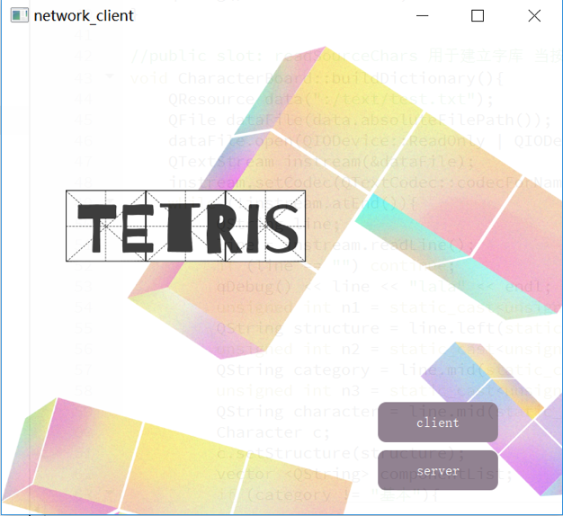

This interface allows the player to choose if he wants to be client or server. If client bottom is clicked, the next interface will be

Figure 2.3.2: Client Interface

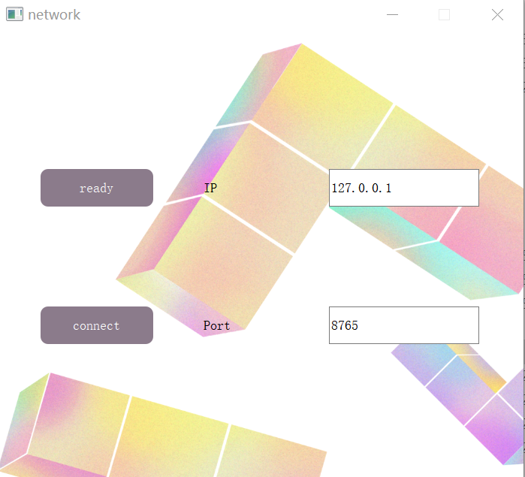

If server bottom is clicked, the next interface will be

Figure 2.3.3: Server Interface

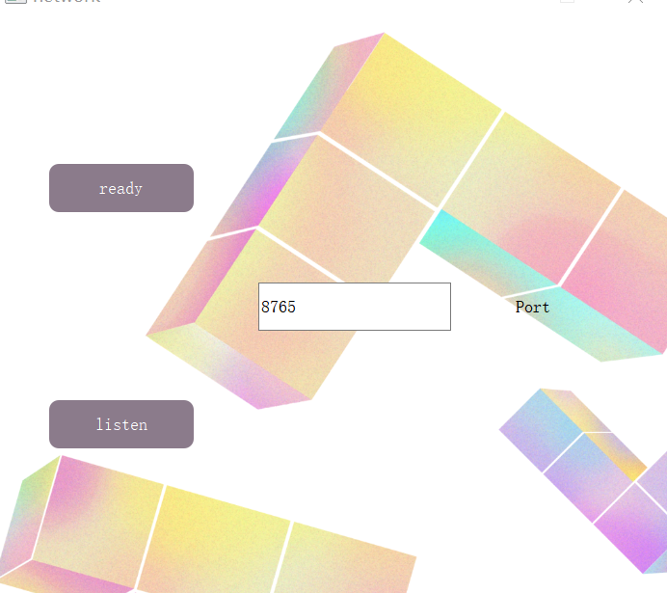

2.3.2 Client and Server Connection

Players should input the server IP and the same port in order to be connect. Server should press the listen bottom first. Client can only press the connect bottom as long as server allows others to connect (press the listen bottom). If connection failed, the program will print “connect failed” in the control panel in Qt and allows the player to reconnect. If succeed, the program will print “connect successfully” in the control panel in Qt and change the connect bottom into disconnect which allows the user to disconnect.

Figure 3.4 on_pushButton_Connect_clicked Function Implementation

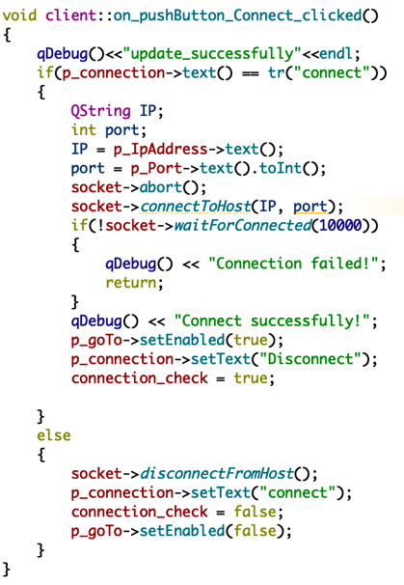

These methods are completed by setEnabled function supported by Widget and network connection is supported by Qsockect library.

As long as clients are disconnected, the ready bottom will be disabled.

Figure 3.5 socket_Disconnected Function for Client



Server is developed by the same method; the program will print “listen successful” as long as the port is bound. server_New_Connect function is used to detect the new connection and the ready bottom will be enabled as long as the two computers are connected.

Figure 3.6 socket_Disconnected Function for Server



Figure 3.7 server_New_Connection Function



2.3.3 Client and Server Information Communication

In network mode, when game is over, the player will get scores of own and the other player. The own score will be sent step by step from character_board.cpp to server.cpp or client.cpp. The opponent’s score will be sent to server.cpp or client.cpp when he finishes the game. After collecting the two scores, the two numbers will be compared to determine who wins.

During this procedure, signals and slots are frequently used and signals will be passed through a chain of files which will be executed during the different process of game.

Figure 3.8: Information Communication implementation

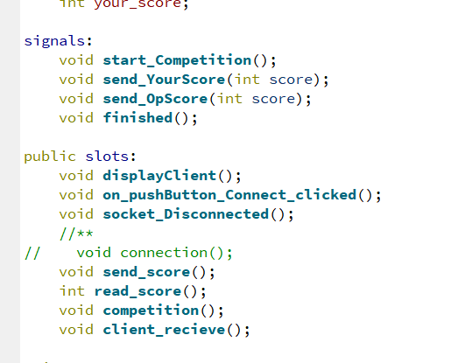

The result file will finally show the competition result. The program will automatically show you the winner and the score of both client and server. (interface截图)

Figure 3.9 Result Interface

**2.4 Multithreading**

The thread file is for multithreading implement. We mainly divided the whole file into seven threads including one main thread and six sub threads. Different sub threads are divided by functions including oneLineDown, setRandomNext, mode_selection, start, pause, removeCombination in order to control different methods in whole programming. All these sub threads will be executed while the start flag is true and pause flag is false.

Figure 2.4.1: thread implementation



In the character board file, we new the thread file and add mutex to protect functions which will be possibly called by different threads simultaneously.

Figure 2.4.2: mutex and functions



**Test Result**

1. When the “Music” checkbox is selected, the background music can be played. After cancel the selection, the music will stop playing.

|  |
| --- |
| Figure 3.1.1. The start interface |
|  |

1. The “Help” connects to the help interface.

|  |
| --- |
| Figure 3.1.2. The help interface |
|  |

1. When the three mode buttons are clicked, the game interface will show up.

|  |
| --- |
| Figure 3.1.3. The game interface |
|  |

1. After the game stops, the score interface will appear.

|  |
| --- |
| Figure 3.1.4. The score interface |
|  |

1. When the “Quit” button is clicked, the program ends.

**Conclusion**

To conclude, we implement our Chinese Character version of Tetris through graph user interface, character board and networking. Although there are many problems left, it is still an innovative game. We will keep working and trying to improve our program in the future.